Algebraic Methods- Mark Scheme
Jan 2013 Mathematics Advanced Paper 1: Pure Mathematics 4

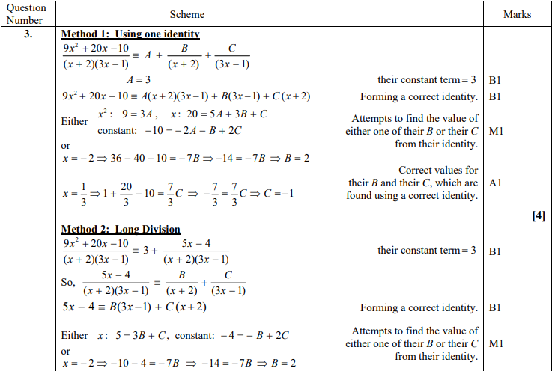
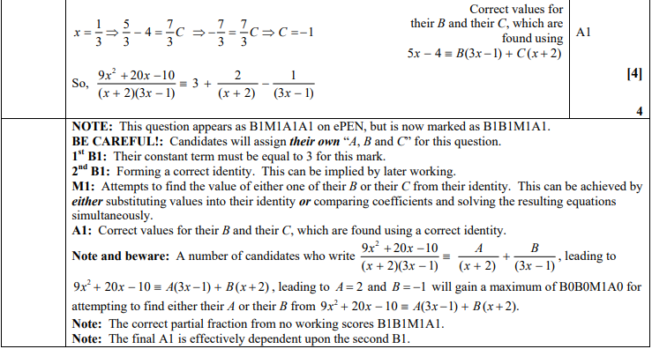
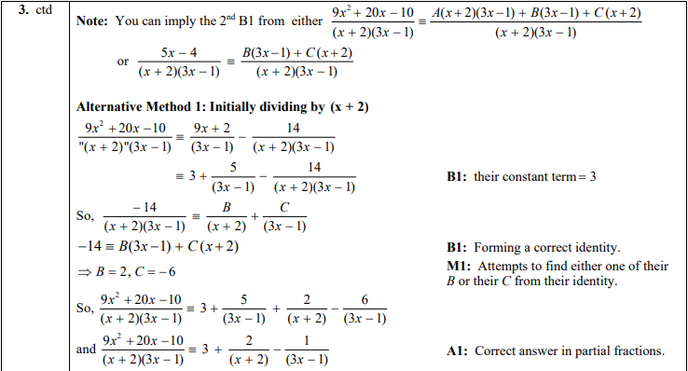
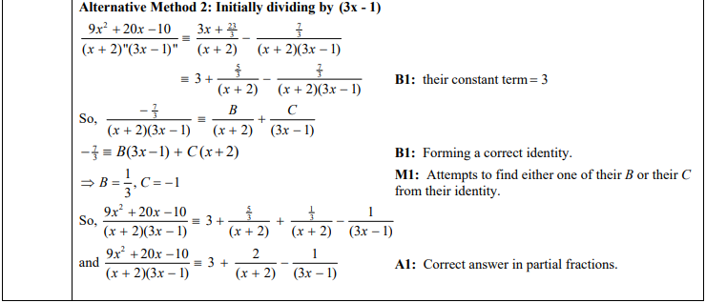

June 2011 Mathematics Advanced Paper 1: Pure Mathematics 4

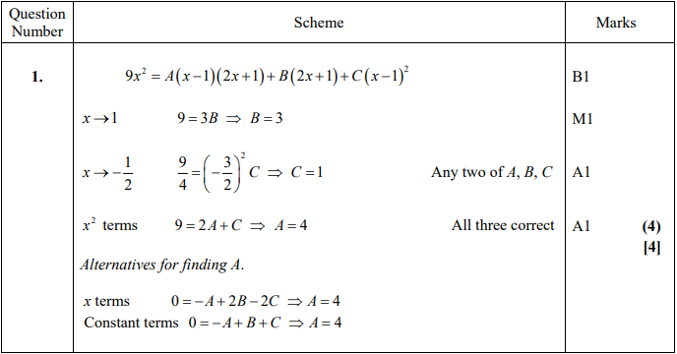

June 2010 Mathematics Advanced Paper 1: Pure Mathematics 4

